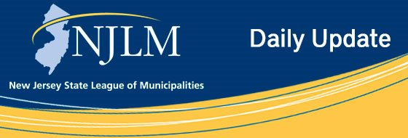
Click to view newsletter archives

View a Featured Ad at the End of this Email.

May 7, 2019
I. NJILGA Mid-Year Seminar
II. Municipal Green Infrastructure Toolkit Workshop

I. NJILGA Mid-Year Seminar

Saturday, June 8, 2019
8:30 a.m. – 12:15 p.m.
Conference Center at Mercer
1200 Old Trenton Road
Princeton Junction, NJ 08550
Agenda:
8:30 a.m. Registration– Continental Breakfast / Coffee
9:00 a.m. Issues regarding the Use of Social Media
10:00 a.m. Employment Law Update
11:00 a.m. Networking Break
11:15 a.m. Professional and Ethical Obligations of Municipal Attorneys
12:15 p.m. Adjourn
Registration Fee: Member Price - $25 Non-member Price - $75
CEUs: NJCLE 3.6 including 1.2 Ethics
Registration Information: To register for the event, please visit the registration webpage
If you have any questions regarding the event, please Email Sherri Smith, Director of Marketing, PARKER McCAY P.A.

II. Municipal Green Infrastructure Toolkit Workshop
An explainer for municipal officials and planning and zoning board members on how to take advantage of New Jersey Future's Green Infrastructure Municipal Toolkit , a guide to encouraging green infrastructure as part of both private and public-sector development. The event, which is presented by New Jersey Future, is free, but space is limited, so registration is required.
Where: Evesham Public Library, 984 Tuckerton Road, Evesham
When: Tuesday, May 14, 6:00 to 8:00 pm
For more information contact: Kandyce Perry, Planning and Policy Manager, New Jersey Future, 609-393-0008, ext. 108.
Registration

Advertiser Spotlight

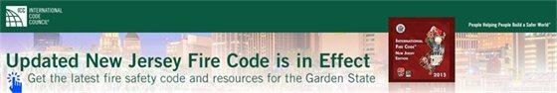



NJLM on Social Media: Facebook Twitter LinkedIn YouTube

  Share on Facebook
  Share on Twitter
  Share via Email

  Copyright 2018 NJLM. All Rights Reserved.
  222 West State Street, Trenton, NJ 08608
  If you no longer wish to receive emails from us, you may Unsubscribe.
  Powered by

Email not displaying correctly? View it in your browser.

