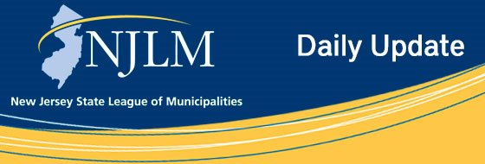
Click to view newsletter archives

View a Featured Ad at the End of this Email.

April 1, 2019
I. Mayors Roundtable Events on Cannabis and Affordable Housing – Elected and
Professionals Too!
II. How to Celebrate 1st NJ Local Government Week April 7-13!
III. One Year Until Census 2020 Day
IV. Free Technology Summit in Trenton

I. Mayors Roundtable Events on Cannabis and Affordable
Housing – Elected and Professionals Too!
The League is proud to present a Mayors’ Roundtable discussion on the topics of Affordable Housing and Cannabis. These topics will be the focus of moderated discussions involving your questions, presentations by helpful experts, and status review of legislation. The topics will be the same at each of the three dates and locations. The moderated discussions and presentations will focus on your concerns. The moderated discussions and presentations will focus on your concerns so send us your specific questions in advance to Danielle Holland-Htut, Continuing Education/ Special Programs Manager, dholland@njlm.org with the subject line “Mayors’ Roundtable Question”
Cannabis: The League has not taken a position on legalization but has done significant research on municipal experiences in other states. See what other states’ facilities look like and learn how other communities have been impacted by this new industry. Get your questions answered and take important information back to your residents and governing body. Gain an understanding of how other municipalities are planning to address this new industry and how the State plans to regulate it.
Affordable Housing: No two communities’ solutions to housing needs are the same. Learn from the variety of approaches that have been implemented. Understand the current situation in various parts of the state and learn where legislative efforts may be focused.
The events will run 9:00 a.m.-12:00 noon.
For information on these events and to register, click on each of the dates below:
Saturday, April 13, 2019, Hilton Hotel, 2 Meadowlands Plaza, East Rutherford, NJ 07073
Tuesday, April 16, 2019, Hotel ML, 915 Route 73, Mount Laurel, NJ 08054
Monday, April 29, 2019,Princeton Marriott at Forrestal, 100 College Road East, Princeton, NJ 08540

II. How to Celebrate 1st NJ Local Government Week
April 7-13!
The 1st NJ Local Government Week is approaching quickly; have you started planning yet?
NJ Local Government week creates an opportunity to let your residents know about your municipal facilities and careers, and highlight the services that their local government provides on a daily basis.
Visit the League website for a how to packet with ideas ranging from basic, no cost activities to some that are more complex.
Want the League to share the events that your municipality is planning to hold? Complete this form on the League website and let us help you spread the word! Share your activities and event photos with the League so that we may share on the League’s website, social media and in NJ Municipalities magazine.
And remember to use the #NJLocalGovt on social media.

III. One Year Until Census 2020 Day
The 2020 Census is approaching, offering municipalities an opportunity to create an accurate population picture that will impact planning on the local, state, and federal levels for years to come. Visit the League Census page, for an action guide, presentations and much more. See how municipalities can best prepare for the Census and utilize the information delivered.

IV. Free Technology Summit in Trenton
The 2019 New Jersey Digital Government Summit is an annual free event for state and local government leaders to participate in informational sessions involving the topic of technology. The event fosters the discussion on the use of information technology as a strategic tool for managers, executive and policy makers, and presents an opportunity to see the latest in digital government solutions, keep abreast of current policy issues and network with industry specialists. The 2019 Summit will be held May 21 & 22 at The War Memorial in Trenton.
Event attendance is geared towards anyone involved in local government that participates in technology decisions or implementation at any level. Event registration, agenda and details can be found online. Registration is limited, and the event will fill up, so if you are interested in attending it is recommended to register early.

Advertiser Spotlight



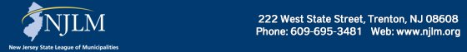

NJLM on Social Media: Facebook Twitter LinkedIn YouTube

  Share on Facebook
  Share on Twitter
  Share via Email

  Copyright 2018 NJLM. All Rights Reserved.
  222 West State Street, Trenton, NJ 08608
  If you no longer wish to receive emails from us, you may Unsubscribe.
  Powered by

