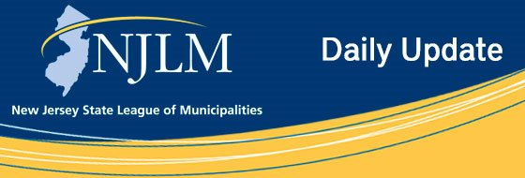
Click to view newsletter archives

View a Featured Ad at the end of this email.

October 15, 2018
I. Are You Ready for the Annual Conference Week?
II. New - League Publication Updated! Municipal Parking & Recreation Fees
III. Don’t Forget! CEU Tracking System Procedures for 103rd Annual NJLM Conference

I. Are You Ready for the Annual Conference Week?
The Conference App is available now! Search sessions, CEUs, exhibitors and participating consultants. Save a personalized schedule so that you don’t miss a thing!
Download by visiting your app store! For app FAQ’s visit the League’s website.
If you downloaded the app last year, you must download the 2018 version to view information for the current year.
The 2018 Conference App is Exclusively Sponsored by AT&T.

II. New - League Publication Updated! Municipal Parking &
Recreation Fees
The League is pleased to announce an update of its License Series: Volume 4. This book lists municipal fees for metered parking, train station lots, residential areas and parking enforcement. It also provides recreation fees for soccer, basketball, football, bowling, tennis, swimming, lacrosse, cricket, baseball, softball, volleyball, golf, adult exercise programs, summer camp, street hockey, youth ice hockey, therapeutic recreation, and before/after school day care. Data for 259 municipalities are included in this book.
Included with this book are Microsoft Excel files of the data. Visit the League website to purchase.
League contact for orders: Suzanne Allen, sallen@njslom.org, 609-695-3481 ext. 129.

III. Don’t Forget! CEU Tracking System Procedures for
103rd Annual NJLM Conference
Badge Scanners will be used to track CEU Credits and Attendance at the NJLM 103rd Annual Conference.
For Sessions that Have CEU credit Available
• All Attendees looking to earn credit must scan-in and scan-out of these qualifying sessions* to earn their CEU credits.
• Attendees will claim their certificates after the conference via the League website www.njslom.org/confceu/
For more information or for a complete list of procedures please visit the Conference Website.
* Please note, the procedures described above only apply to educational sessions. Business Meetings and Exhibitor Learning Sessions are not included in the scanning system.

Advertiser Spotlight

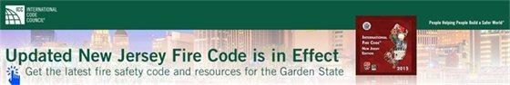



NJLM on Social Media: Facebook Twitter LinkedIn YouTube

  Share on Facebook
  Share on Twitter
  Share via Email

  Copyright 2018 NJLM. All Rights Reserved.
  222 West State Street, Trenton, NJ 08608
  If you no longer wish to receive emails from us, you may Unsubscribe.
  Powered by

