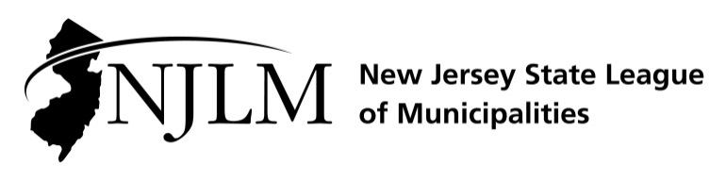
222 West State Street, Trenton, NJ 08608
Phone: 609-695-3481 www.njlm.org

February 12, 2025
Contact: Michael F. Cerra, Executive Director, NJLM
609-695-3481 x 120, mcerra@njlm.org

Media Advisory

NJLM Promotes Paul Penna to Director of Government Affairs
Trenton, NJ (February 12, 2025) – After joining the League in 2020 as a Legislative Analyst, and later as a Senior Legislative Analyst, Paul Penna has been promoted to Director of Government Affairs for the New Jersey State League of Municipalities effective January 2, 2025, and will focus on managing the League’s advocacy initiatives.
League Executive Director Mike Cerra and Deputy Executive Director Lori Buckelew will continue to engage on key legislative and regulatory issues while Penna will have a visible presence at the Statehouse and advocate on behalf of the interest of the League’s municipal members.
“From his first day, Paul has been a team player and problem solver” stated Michael F. Cerra, NJLM Executive Director. “He has been a fierce advocate for municipal issues before the state legislature, the state executive branch, as well as Congress and the federal executive branch on issues as varied as Workers’ Compensation cost increases issues, elimination of the SALT cap deduction, and the continued issues surrounding the State Health Benefits Program.”
Penna’s long and varied experience includes owning his own consulting business focused on communication and association management, serving as the Chief of Staff at the New Jersey Department of Banking and Insurance, and holding staff positions for multiple New Jersey Governor’s and a Member of Congress.
“Elected officials have relied on Paul to advance municipal issues in New Jersey” said League President and Alpine Mayor Paul Tomasko. “His subject matter expertise is invaluable for municipal governing leaders.”
In the community, Penna has previously served on his local Planning Board in the Township of Lawrence as an alternate member, member, Vice Chair, and Chair. He also served as a member of the Mercer County Planning Board member. He is currently a parent softball volunteer, on the Board of the Rutgers Alumni Association, and on the Board of Lawrenceville Main Street. He resides in Lawrence Township with his wife and daughters.

Follow the League on X & Facebook at twitter.com/NJ_League & facebook.com/njleague

