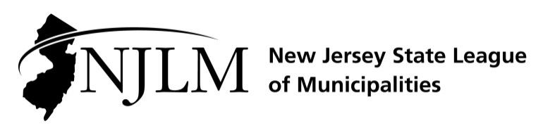
222 West State Street, Trenton, NJ 08608
Phone: 609-695-3481 www.njlm.org

November 22, 2024
Contact: Michael Cerra, Executive Director, NJLM
mcerra@njlm.org, 609-695-3481, Ext. 120

Media Advisory

NJLM Membership Elected New Officers, Executive Board

Trenton, NJ (November 22, 2024) On Thursday, November 21, 2024, New Jersey’s mayors elected new officers and executive board members for the New Jersey State League of Municipalities. These public servants will help lead the Association that represents New Jersey’s 564 municipal governments. They will represent the interests and needs of New Jersey’s local elected officials to county, state and federal governments, the courts, and the media.

Mayor Paul Tomasko of Alpine was elected President of the New Jersey State League of Municipalities. Mayor Sean Elwell of Elsinboro was elected to the position of First Vice President, Mayor Shelley Brindle of Westfield and Mayor Guy Piserchia serve as Second and Third Vice Presidents, respectively.

To learn more about these officers, visit the League’s website at www.njlm.org/ExecutiveBoard.

In addition, this year the League has added four at-large Executive Board members, an option that was added to the bylaws at last year's business meeting to expand the board and ensure that it was representative of the state as a whole.

A list of the new officers and executive board members is attached.

For more information, please contact Michael Cerra; Executive Director, at 609-695-3481, via email, at mcerra@njlm.org

2024-2025 LEAGUE OFFICERS AND EXECUTIVE BOARD

PAUL TOMASKO, President
Mayor, Alpine

SEAN ELWELL, 1st Vice President
Mayor, Elsinboro

SHELLEY BRINDLE, 2nd Vice President
Mayor, Westfield

GUY PISERCHIA, 3rd Vice President
Mayor, Long Hill

EXECUTIVE BOARD

RAS BARAKA
Mayor, Newark

TOM BIANCO
Mayor, Clayton

MARY JANE CANOSE
Mayor, Bernardsville

WILLIAM CHEGWIDDEN
Mayor, Wharton; Immediate Past President, NJLM

BRAD COHEN
Mayor, East Brunswick

SHEENA COLLUM
Village President, South Orange

RUBY COTTON
Council Member, Paterson

WILLIAM CURTIS
Mayor, Bay Head

DAVID DeGIRALAMO
Mayor, Union Township (Hunterdon)

ANTHONY FANUCCI
Mayor, Vineland

ELSIE FOSTER
Mayor, Highland Park

STEVEN FULOP
Mayor, Jersey City

JOHN C. GLIDDEN JR.
Mayor, Closter

DINA GRILO
Mayor, East Newark

BARBARA JUZAITIS
Councilwoman, Avalon

NICK KAPPATOS
Mayor, Runnemede

M. JAMES MALEY JR.
Mayor, Collingswood

ADRIAN O. MAPP
Mayor, Plainfield

JEFFREY MARTIN
Mayor, Hamilton

JOHN PALLONE
Mayor, Long Branch

JANET W. TUCCI
Mayor, West Long Branch

ROSEMARY TUOHY
Mayor, Allamuchy Township

JACLYN VEASY
Mayor, Evesham

