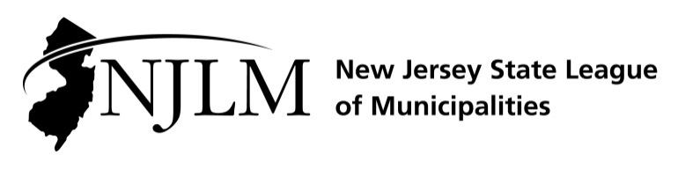
222 West State Street, Trenton, NJ 08608
Phone: 609-695-3481 www.njlm.org

November 25, 2024
Contact: Michael Cerra, Executive Director, NJLM
mcerra@njlm.org, 609-695-3481, Ext. 120.

Media Advisory

Cowling-Carson, Hoven, McCall-Fisher, Suárez, and White, Recognized for Achievements by League Women in Municipal Government Committee

Trenton, NJ (November 25, 2024). Recognizing the contributions and dedicated service toward the advancement of women in municipal government, the NJ State League of Municipalities’ Women in Municipal Government Committee has celebrated the work of Magnolia Mayor BettyAnn Cowling-Carson, Chester Borough Mayor Janet Hoven, Della McCall Fisher, Director of Community Engagement and Filming Coordinator, City of Paterson, Department of Community Affairs Commissioner and Division of Local Government Serves Jacquelyn Suárez, and Eastampton Township Municipal Clerk, Local Registrar, Township Manager, and Qualified Purchasing Agent Kim-Marie White.
The honorees were celebrated at the Women in Municipal Government (WIMG) Networking & Awards Event on Wednesday, November 20 at the League’s 109th Annual Conference in Atlantic City.
WIMG was established by the League of Municipalities’ Executive Board to encourage active involvement and full participation of elected female municipal officials in local government.
For more information, contact Executive Director Michael Cerra at 609-695-3481, ext. 120.
Follow the League on Twitter & Facebook at twitter.com/NJ_League & facebook.com/njleague

