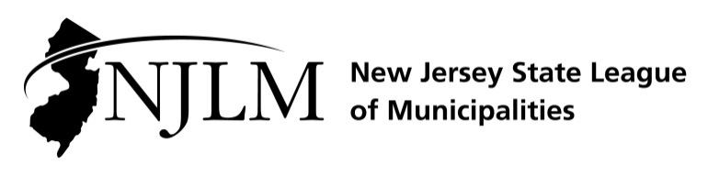
-
222 West State Street, Trenton, NJ 08608
Phone: 609-695-3481 www.njlm.org

November 25, 2024
Contact: Michael Cerra, Executive Director, NJLM
mcerra@njlm.org, 609-695-3481, Ext. 120.

Media Advisory

Pascrell, Payne, and Kearns Honored at League Luncheon

Trenton, NJ (November 25, 2024). The NJ State League of Municipalities recognized the outstanding contributions to municipal government of the late Representative Bill Pascrell, the late Representative Donald M. Payne Jr., and William Kearns Jr., Esq., League Counsel, at the Annual League Luncheon on Thursday, November 21. The event, which featured a keynote speech by Gov. Phil Murphy, brought local and state officials together to engage and celebrate the important contributors to the betterment of local government.
Since 2003, NJLM’s Executive Board and officers have honored individuals who have made substantial, longstanding contributions to the state of New Jersey through their Distinguished Public Service Awards. This year, Pascrell and Payne are posthumously recognized for their lifetime of dedication with the 2023 Distinguished Public Service Award presented by Governor Phil Murphy and outgoing NJLM President Mayor William Chegwidden of Wharton. The NJLM Distinguished Public Service Award is presented to individuals and organizations that have, over time, made substantial contributions to the State of New Jersey through their distinguished public service.
Then-President Chegwidden presented Kearns with the Public Sector Career Recognition Award, which is presented to individuals who have devoted their professional lives to excellence in Local Government, providing municipal officials with assistance, innovations, and guidance.
For more information, contact Executive Director Michael Cerra, at 609-695-3481, ext. 120.
Follow the League on Twitter & Facebook at twitter.com/NJ_League & facebook.com/njleague

