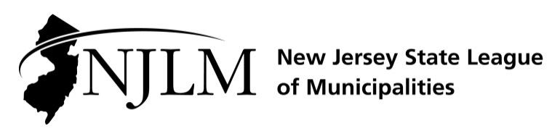
222 West State Street, Trenton, NJ 08608
Phone: 609-695-3481 www.njlm.org

November 25, 2024
Contact: Michael Cerra, Executive Director, NJLM
mcerra@njlm.org, 609-695-3481, Ext. 120.

Media Advisory

2024 Innovation in Governance Award Program

Trenton, NJ (November 25, 2024). The New Jersey Department of Community Affairs and the New Jersey State League of Municipalities continue to recognize Innovation in Governance through their annual awards program. The awards are presented as part of the Mayors’ Lunch Briefing on Wednesday, November 20, during the Annual League Conference in Atlantic City.

This award program was established to highlight exemplary local government programs that provide innovative and practical approaches to solving municipal problems and concerns. At the same time, we share these innovative approaches with municipal leaders throughout the state at the Annual New Jersey State League of Municipalities Conference, and through the National League of Cities’ “Best Practices” database.

The 2024 judges were: League Past Presidents Paul Matacera and Plainsboro Mayor Peter Cantu,
Deputy Director of the Division of Local Government Services Michele Meade, and New Jersey State League of Municipalities Executive Director Michael Cerra.

The program invited applications describing any type of innovation undertaken by municipalities in the past 12 months. The participants responded with a range of submissions that underscore the variety of challenges municipalities solve.

The 2024 Innovation in Governance Awards go to:

Jersey City: TMI, LLC Pastor John H. McReynolds Teen Magazine Literacy Program

Deerfield: #Deerfieldpride program

See the full details by visiting njlm.org/innovation-in-governance

Follow the League on Twitter & Facebook at twitter.com/NJ_League & facebook.com/njleague

