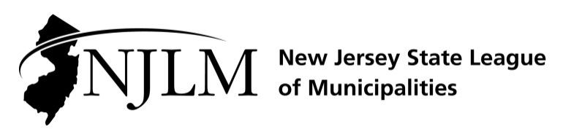
222 West State Street, Trenton, NJ 08608
Phone: 609-695-3481; www.njlm.org

November 22, 2024
Contact: Michael Cerra, Executive Director, NJLM
mcerra@njlm.org, 609-695-3481, Ext. 120.

Media Advisory

Mayor Piserchia Elected NJLM 3rd Vice President

Trenton, NJ – Mayor Guy Piserchia is the new 3rd Vice President of the New Jersey State League of Municipalities. Mayor Piserchia was elected at the League of Municipalities’ Annual Business Meeting in Atlantic City.
As 3rd Vice President of the New Jersey State League of Municipalities, Mayor Piserchia will help lead the Association of New Jersey’s 564 municipal governments. He will represent the interests and needs of New Jersey’s local elected officials to county, state, and federal governments.
Mayor Piserchia of Long Hill has served on the Executive Board since November 2018. He started his local government service in 2002 as a member of Long Hill Township’s Board of Adjustment and was a member of the Planning Board from 2010 to 2015. He has served as Mayor 2012-15, 2017, 2019, 2021, and 2024 and has been a member of the Township Committee since 2010.

Mayor Piserchia is a member of the New Jersey League of Municipalities Legislative Committee; New Jersey Conference of Mayors Legislative Committee; Morris County League of Municipalities Executive Board (President 2020, 2021); Morris County Open Space Trust Fund Committee (Vice chairman, termed out); Great Swamp Watershed Association Board of Trustees, Executive Board, Treasurer; Great Swamp National Wildlife Refuge Municipal Alliance; New Jersey Prayer Breakfast Steering Committee; and With Grace Initiative Board Member.

An international banking professional with extensive trading and management experience, he is currently with the New Jersey Division of Investments. Mayor Piserchia has his bachelor’s degree and masters of business administration from Seton Hall University.

For more information, contact Executive Director Michael Cerra at 609-695-3481, ext. 120.

