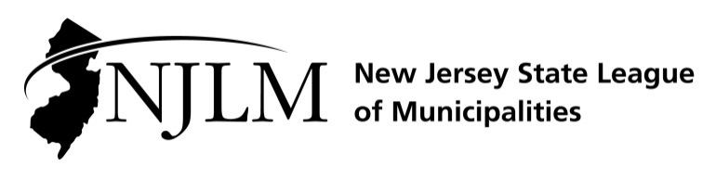
222 West State Street, Trenton, NJ 08608
Phone: 609-695-3481 www.njlm.org

November 20, 2024
Contact: Michael Cerra, Executive Director, NJLM
mcerra@njlm.org, 609-695-3481, Ext. 120.

Media Advisory

Mayor Shelley Brindle Elected NJLM 2nd Vice President

Trenton, NJ – Mayor Shelley Brindle of Westfield is the new 2nd Vice President of the New Jersey State League of Municipalities. Mayor Brindle was elected at the League of Municipalities’ Annual Business Meeting in Atlantic City.
As 2nd Vice President of the New Jersey State League of Municipalities, Mayor Brindle will help lead the Association of New Jersey’s 564 municipal governments. She will represent the interests and needs of New Jersey’s local elected officials to county, state, and federal governments.
Mayor Shelley Brindle of Westfield. She was elected as the town’s first female mayor in 2017 and reelected in 2021. Mayor Brindle joined the League’s Executive Board in November 2022.

Mayor Brindle co-founded the Raritan Valley Line Mayors’ Alliance; serves as chair on NJ League of Municipalities’ Liquor License Reform Task Force; led Westfield’s sustainability efforts resulting in first time Silver Certification award by Sustainable Jersey; achieved first-time state professional accreditation for the Westfield Police Department; named 2022 Mayor of the Year by the Gateway Regional Chamber of Commerce; and was awarded an Innovation in Governance Award by NJLM and the DCA in 2019.

Previously, Mayor Brindle served as HBO’s Executive Vice President, Domestic Network Distribution & Marketing, and the first female in HBO’s C-suite.

Mayor Brindle also serves on the Board of Directors at Philo, and the Board of Directors for W.O.M.E.N. In America (WIA), as a Global Ambassador for Vital Voices, is a founding member of Extraordinary Women on Boards (EWOB) and serves as an advisor and mentor to the University of Chicago’s Leadership & Society Initiative.

Mayor Brindle lives in Westfield with her husband Kip, their three children and two rescue dogs, and any number of foster dogs waiting for their forever homes.

For more information, contact Executive Director Michael Cerra at 609-695-3481, ext. 120.

