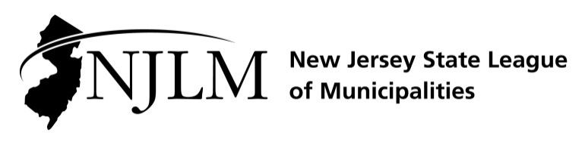
222 West State Street, Trenton, NJ 08608
Phone: 609-695-3481 www.njlm.org

November 22, 2024
Contact: Michael Cerra, Executive Director, NJLM
mcerra@njlm.org, 609-695-3481, Ext. 120.

Media Advisory

Mayor Elwell Elected NJLM 1st Vice President

Trenton, NJ - Mayor Sean Elwell of Elsinboro is the new 1st Vice President of the New Jersey State League of Municipalities. Mayor Elwell was elected at the League of Municipalities’ Annual Business Meeting in Atlantic City.
As 1st Vice President of the New Jersey State League of Municipalities, Mayor Elwell will help lead the Association of New Jersey’s 564 municipal governments. He will represent the interests and needs of New Jersey’s local elected officials to county, state, and federal governments.
Prior to his appointment as Mayor in 2011, he served as Deputy Mayor starting in 2007. He also served as a member of the Executive Board of the League of Municipalities until his election as vice president. His work with the League has included moderating and serving as panelist for the League in addition to writing for NJ Municipalities magazine.
A registered nurse, Elwell holds many certifications including Emergency Medication Technician, Boad Certified Nurse, and Trauma Certified Registered Nurse. He is currently Senior Director of Nursing, Trauma, Critical Care Transport, and Emergency Department for Nemours Children’s Hospital Delaware and is also a Clinical Faculty member at Neumann University.
Elwell is a graduate of Cumberland County College with an Associate degree, Drexel University with a Bachelor and Master of Science in Nursing, and he completed his Doctor of Nursing Practice from Wilmington University in 2023.
For more information, contact Executive Director Michael Cerra at 609-695-3481, ext. 120.

