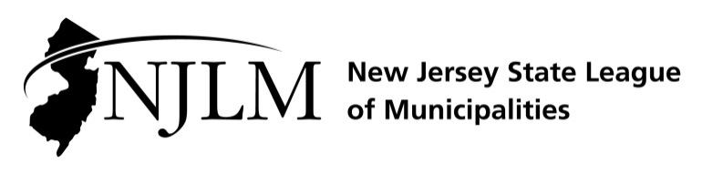
222 West State Street, Trenton, NJ 08608
Phone: 609-695-3481 www.njlm.org

November 25, 2024
Contact: Michael Cerra, Executive Director, NJLM
mcerra@njlm.org, 609-695-3481, Ext. 120

Media Advisory

Mayor Mary Jane Canose Elected to Serve on NJLM Executive Board

Trenton, NJ – On Thursday, November 21, 2024, at their annual business meeting in Atlantic City, the membership of the New Jersey State League of Municipalities elected Mayor Mary Jane Canose of Bernardsville to serve on the Executive Board of the New Jersey State League of Municipalities.
As a member of the League’s Executive Board, Mayor Canose will help lead the Association of New Jersey’s 564 municipal governments. Mayor Canose will represent the interests and needs of New Jersey’s local elected officials to county, state, and federal governments.
The New Jersey State League of Municipalities is a voluntary non-partisan association created to enhance the ability of New Jersey’s municipal governments to represent their constituents by acting as an advocate for New Jersey municipalities before the State and federal government; serving as a definitive information clearinghouse and providing educational opportunities for elected and appointed officials; and providing networking opportunities and forums for discussions and sharing of mutual concerns. All 564 mayors and 13,000 elected and appointed officials of member municipalities are entitled to all the services and privileges of the League. All 564 mayors and 13,000 elected and appointed officials of member municipalities are entitled to all the services and privileges of the League.
For more information, contact Executive Director Michael Cerra at 609-695-3481, ext. 120.

