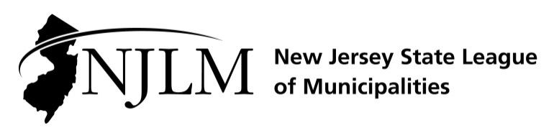
222 West State Street, Trenton, NJ 08608
Phone: 609-695-3481 www.njlm.org

November 25, 2024
Contact: Michael Cerra, Executive Director, NJLM
mcerra@njlm.org, 609-695-3481, Ext. 120.

Media Advisory

Long-serving Leaders Inducted to NJLM Mayors’ Hall of Fame

Trenton, NJ (November 25, 2024). At the 109th Annual New Jersey League of Municipalities Conference in Atlantic City, then League President William Chegwidden and officials from throughout New Jersey honored the most recent inductees to the Mayors’ Hall of Fame.

The League established the Mayors’ Hall of Fame to recognize mayors who have served for over 10, 20, or 30 years. “Serving as mayor for decades is a commitment of time and energy over the long haul. These mayors have sincerely made a long-term commitment as leaders to guide and improve their communities. They have helped their communities grow and change over the years, and have worked to make a positive impact,” said League Executive Director Michael Cerra. “We congratulate them on their deserved recognition.”

The following members of the 30th induction class of the Mayors’ Hall of Fame were honored during a special ceremony during the Mayors’ Lunch Briefing on Wednesday, November 20 in Atlantic City.

Platinum level (30 or more years)
Mayor Christian Bollwage, Elizabeth City
Mayor Richard Turner, Weehawken Township

Gold level (10 or more years)
Mayor Daniel J. Reiman, Carteret Borough
Mayor M. James Maley, Collingswood Borough
Mayor Thomas W. Fromm, Swedesboro Borough
Mayor John Coiro, Totowa Borough

Silver level (10 or more years)
Mayor William Curtis, Bay Head Borough
Mayor John Glidden, Closter Borough
Mayor Paul Medany, Deptford Township
Mayor Dale Archer, East Greenwich Township
Mayor Tony Vauss, Irvington Township
Mayor Russell Felter, Jefferson Township
Mayor Raymond Coles, Lakewood Township
Mayor Derek Armstead, Linden City
Mayor James Barsa, Norwood Borough
Mayor Jay Gilliam, Ocean City
Mayor Adrian O. Mapp, Plainfield City
Mayor David Fried, Robbinsville Township

For the full Mayors’ Hall of Fame, please visit www.njlm.org/mayorsHOF

Follow the League on Twitter & Facebook at twitter.com/NJ_League & facebook.com/njleague

