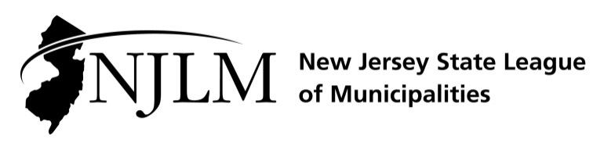
222 West State Street, Trenton, NJ 08608
Phone: 609-695-3481 www.njlm.org

November 25, 2024
Contact: Michael Cerra, Executive Director, NJLM
mcerra@njlm.org, 609-695-3481, Ext. 120.

Media Advisory

NJLM Elected Officials’ Hall of Fame Inductees Recognized

Trenton, NJ (November 25, 2024). At the 109th Annual New Jersey League of Municipalities Conference in Atlantic City, then League President William Chegwidden and officials from throughout New Jersey honored the most recent inductees to the Elected Officials’ Hall of Fame.

The New Jersey State League of Municipalities inaugurated the Elected Officials Hall of Fame during the Seventh Annual Mayors Legislative Day January 27, 1999, at the State House Annex in Trenton.

The honor is reserved for local municipal governing body members, active and retired, who have served for 20 or more years as a governing body member.

The following members of the induction class of the Elected Officials’ Hall of Fame were honored during a special ceremony during the Mayors’ Lunch Briefing on Wednesday, November 20 in Atlantic City.

Councilwoman Gayle Gerstein, Alpine Borough
Councilman Rovell Steven J. Rovell, Belleville Township
Councilman John J. Notari, Belleville Township
Councilwoman Marie Strumolo-Burke, Belleville Township
Council Member Angel Albanese, Clark Township
Mayor Paul Medany, Deptford Township
Councilwoman Jeanne Zincavage, East Newark Borough
Council President Manuel Grova, Elizabeth City
Councilwoman Katherine Mitchell, Fanwood Borough
Mayor Kevin A. Kane, Freehold Borough
Mayor Michael C. Sachs, Hazlet Township
Committeeman/Deputy Mayor John J. Ciccarelli, Hillsborough Township
Mayor Emeritus Timothy Donahue, Middle Township
Councilman Tom Brizzolara, Norwood Borough
Council President Gary Schaer, Passaic City
Committeeman Neil J. Lewis, Plainsboro Township
Commissioner John Anlian, Ridgefield Park Borough
Councilman Thompson Mitchell, Somerville
Borough Councilman Salvatore Cassella, Swedesboro Borough
Mayor Richard F. Turner, Weehawken Township
Mayor Marie D. Lawrence, Winslow Township
Mayor Harold A. Pye, Woodbury Heights

For the full Elected Officials’ Hall of Fame, please visit Elected Officials Hall of Fame | New Jersey League of Municipalities.

Follow the League on Twitter & Facebook at twitter.com/NJ_League & facebook.com/njleague

