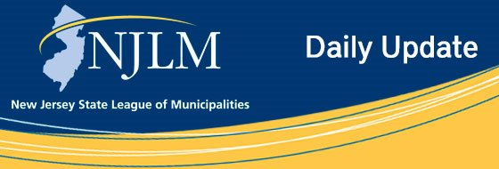
Click to view newsletter archives

View a Featured Ad at the End of this Email.

December 10, 2019
I. Have your own Subscription to NJ Municipalities Magazine Delivered to your Inbox
Each Month!
II. Celebrate your Municipality and Showcase its Beauty!

I. Have your own Subscription to NJ Municipalities Magazine Delivered to your Inbox Each Month!
Want to read about the current initiatives local governments are taking to solve problems in their towns? Want to stay up-to-date on legislation impacting municipalities? Subscribe and never miss an issue of the League magazine. Information on Subscribing is available at our web site.
Contact: Tom Fratticcioli TFratticcioli@njlm.org.

II. Celebrate your Municipality and Showcase its Beauty!
Let residents know about your municipal facilities and careers, and highlight the services that their local government provides on a daily basis by participating in NJ Local Government Week April 19-25, 2020.
The League invites you to join in with municipalities across the Garden State April 19-25, 2020, to engage citizens while celebrating the work of local government. Through NJ Local Government Week, the League hopes to bring awareness to the role local government plays in achieving the best life for communities. Invite your schools, civic groups, businesses, and media to NJ Local Government Week activities for citizens of all ages.
How Can You Celebrate? Visit the League’s website for ideas on celebrating in your municipality; including a “how to” packet with ideas ranging from basic, no cost activities to some that are more complex. Be sure to tag your social media posts with #njlocalgovt, and utilize the NJ Local Government Week logo that the League has provided by downloading from the League website.
Visit the League website for tips, suggestions and a logo created to help promote your events.

Advertiser Spotlight

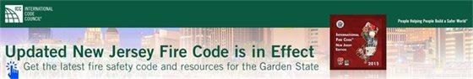



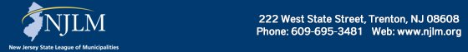

NJLM on Social Media: Facebook Twitter LinkedIn YouTube

  Share on Facebook
  Share on Twitter
  Share via Email

  Copyright 2018 NJLM. All Rights Reserved.
  222 West State Street, Trenton, NJ 08608
  If you no longer wish to receive emails from us, you may Unsubscribe.
  Powered by

Email not displaying correctly? View it in your browser.

