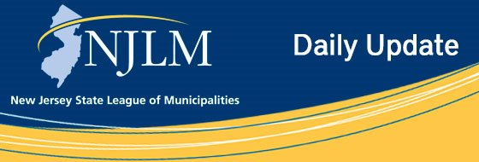
Click to view newsletter archives

View a Featured Ad at the End of this Email.

December 11, 2019
I. Claim Your CEU’s from the 2019 League Conference
II. Register Now for these Upcoming Seminars

I. Claim Your CEU’s from the 2019 League Conference
Attention Municipal Officials! Do Not Forget to Claim Your CEU’s from the 2019 NJLM Annual Conference!
Visit the Conference Tracking page to claim your credits.

II. Register Now for these Upcoming Seminars

a. Orientation for Municipal Officials That Are Newly Elected, Reelected, or Experienced

Saturday, January 11, 2020
8:30 a.m. - 3:30 p.m.
Hilton Meadowlands Hotel
2 Meadowlands Plaza
East Rutherford, NJ 07073
This program is a requirement of the Local Government Leadership Program.
For more information visit the Local Government Leadership Program Page.
Event Details for January 11 Newly Elected Program

b. Orientation for Municipal Officials That Are Newly Elected, Reelected, Or Experienced

Saturday, January 25, 2020
8:30 a.m. - 3:30 p.m.
Westin Hotel
555 Fellowship Road
Mount Laurel, NJ 08054
This program is a requirement of the Local Government Leadership Program.
For more information visit the Local Government Leadership Program Page.
Event Details for January 25 Newly Elected Program

C. Budgeting for the Elected Official: Everything You Need to Know to Create, Balance, and Approve Your Municipalities’ Budget

Saturday, February 22, 2020
8:30 a.m. - 2:00 p.m.
The Conference Center at Mercer
1200 Old Trenton Rd.
West Windsor, NJ 08550
This program is a requirement of the Local Government Leadership Program.
For more information visit the Local Government Leadership Program Page.
Event Details for February 22 Budgeting Program

d. 28th Annual Mayors Legislative Day

Friday, April 3, 2020
8:30 a.m. - 1:00 p.m.
The State House Annex, Committee Room 4
125 West State Street
Trenton, New Jersey
Event Details for April 3 Legislative Day

Advertiser Spotlight

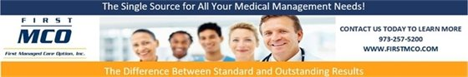

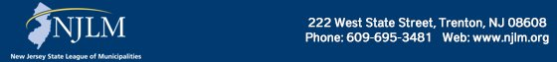

NJLM on Social Media: Facebook Twitter LinkedIn YouTube

  Share on Facebook
  Share on Twitter
  Share via Email

  Copyright 2018 NJLM. All Rights Reserved.
  222 West State Street, Trenton, NJ 08608
  If you no longer wish to receive emails from us, you may Unsubscribe.
  Powered by

Email not displaying correctly? View it in your browser.

