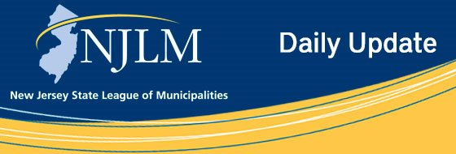
Click to view newsletter archives

View a Featured Ad at the End of this Email.

December 12, 2019
I. Show Off Your City Contest Deadline Feb. 3
II. Police and Fire Contract Provisions – New Data Just Released

I. Show Off Your City Contest Deadline Feb. 3
The Third Annual Show Off Your City Contest is accepting entries through February 3. Municipalities are invited to send us photos of their tourist attractions, downtown areas, economic development initiatives, parks, city halls, community groups and new projects. Entries will be posted on the League’s Facebook page, website and some featured in the April issue of NJ Municipalities, and possibly other issues.
A winner will be chosen and receives a free League publication of their choice! Photos can be submitted to Email: aspiezio@njlm.org, or mailed on CD or flash drive to 222 West State Street, Trenton, NJ 08608.
For full details, visit the Show Off Your City Contest webpage.

II. Police and Fire Contract Provisions – New Data Just Released
Are you getting ready to head into negotiations?
The Police and Fire Labor Data Service provides resources tracking the trends in police and fire contract settlements. The service includes data in Microsoft Excel files. Included are selected contract provisions, such as agreement years, college provisions, travel reimbursement, vacation and longevity schedules, health benefits, and more. Visit the League’s website for the full list of provisions included. Also included are department salary scales, which include a calculation of horizontal and vertical increases for each year.
The League’s goal is to provide its membership with the most current data for the most departments across the State. We began collecting this data in January 2019, and will continue collecting through 2020. However, because we know how important and time sensitive this information is, we are releasing the data in two editions. Available now is the first edition, with all data that has been collected thus far. The second edition is expected to be available as early as March 2020. Once the additional data for the second edition is available, it will be emailed automatically to all those that purchased the first edition.
This first edition includes data for approximately 330 police departments and 50 fire departments.
The data is available electronically, allowing you to easily search and sort through information as it best applies to your municipality. The Police and Fire Labor Data Service is part of the League’s Bureau of Municipal Information.
To order visit the League’s website and complete the order form.
Contact: Suzanne Allen, sallen@njlm.org, 609-695-3481 x129.

Advertiser Spotlight





NJLM on Social Media: Facebook Twitter LinkedIn YouTube

  Share on Facebook
  Share on Twitter
  Share via Email

  Copyright 2018 NJLM. All Rights Reserved.
  222 West State Street, Trenton, NJ 08608
  If you no longer wish to receive emails from us, you may Unsubscribe.
  Powered by

Email not displaying correctly? View it in your browser.

