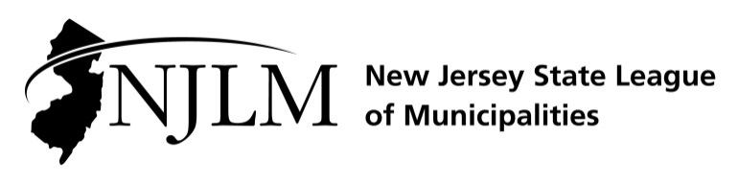
222 West State Street, Trenton, NJ 08608
Phone: 609-695-3481 www.njlm.org

OCTOBER, 10, 2019
Contact: Mike Cerra, Assistant Executive Director & Director of Government Affairs, NJLM
mcerra@njlm.org; 609-695-3481 x120; 609-532-2494.

Media Advisory

League Statement on Governor’s Remarks on
Comprehensive Statewide Plan to Address Lead Exposure

Trenton, NJ (October 10, 2019) In response to the Governor’s remarks today and the release of a series of recommendations, League of Municipalities President Colleen Mahr stated,

“The risk of lead in our drinking water is too critical and too widespread for municipalities to tackle alone. Statewide, over 1.5 million New Jerseyans run the risk of lead poisoning, every time they turn on the tap. For that reason, we applaud the Governor Murphy’s recommendation to seek a November 2020 ballot referendum to authorize $500 million for infrastructure improvements to address the risk of lead in our drinking water and lead paint in our home.

“If any issue should unite us all, it’s our drinking water and a solution requires pragmatic leadership by elected officials at all levels of government. Americans deserves 21st century infrastructure, including easy access to safe, clean drinking water. This is a nationwide emergency. It also demands a national solution.

“We look forward to a review of the recommendations offered by our colleagues at Jersey Water Works. And we look forward to working with the Governor, the Senate President, the Speaker, the full Legislature and our Congressional delegation to develop a comprehensive game plan to remove the risk of lead in our drinking water and homes.”

Colleen Mahr is the Mayor of Fanwood and President of the New Jersey State League of Municipalities. NJLM is a voluntary non-partisan association created to help communities do a better job of self-government through pooling information resources and brain power.

Follow the League on Twitter & Facebook at twitter.com/NJ_League & facebook.com/njleague

