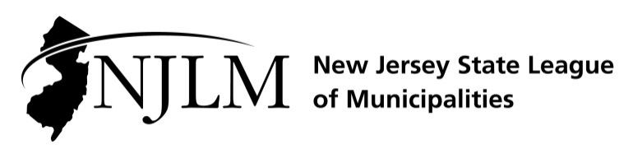
222 West State Street, Trenton, NJ 08608
Phone: 609-695-3481 www.njlm.org

November 21, 2019
Contact: Michael J. Darcy, Executive Director, NJLM
mdarcy@njlm.org, 609-695-3481, Ext. 116

Media Advisory

Outstanding Women in Municipal Government Award Recipients Celebrated

Trenton, NJ (November 21, 2019) The NJ State League of Municipalities’ Women in Municipal Government networking event on Wednesday, November 20, celebrated the 2019 Outstanding Women in Municipal Government Award recipients and the centennial of New Jersey’s ratification of the 19th Amendment extending the vote to women.
Secretary of State Tahesha Way and members of the NJLM Executive Board congratulated the 2019 winners of the Outstanding Women in Government Awards at the NJLM Women in Municipal Government event.
Five elected and professional office holders were recognized for their contributions and dedicated service toward the advancement of women in municipal government. The 2019 winners of the Outstanding Women in Government Award are:
- Wilda Diaz, Mayor, City of Perth Amboy
- Maria DiGiovanni, Mayor, Town of Hackettstown
- Kathleen Canestrino, Deputy Mayor, City of Hackensack
- Patricia Perkins-Auguste, Councilwoman-At-Large, City of Elizabeth
- Caroline Ehrlich, Chief of Staff; Executive Director, Woodbridge Redevelopment Agency, Township of Woodbridge
WIMG was established by the League of Municipalities’ Executive Board to encourage active involvement and full participation of elected female municipal officials in local government.
Biographies of each winner can be found in the Awards section of the League website, www.njlm.org/WIMGawards. For more information, contact Executive Director Michael J. Darcy, CAE, at 609-695-3481 or 609-510-9472 (c).
Follow the League on Twitter & Facebook at twitter.com/NJ_League & facebook.com/njleague

